Find the spy using binary addition
Top secret information has been stolen from a government database and you have just received a coded message which contains the location of the spy. To decrypt the message add up the binary numbers below and convert the results into denary (base 10).
Then go onto the second page and find the letter for each number. This will spell out the location of the spy.

Remember 0+0 =0, 1+0 =1, 0+1=1, 1+1= (carried) 1 0

+ 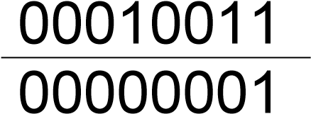
Converted into denary =

+ 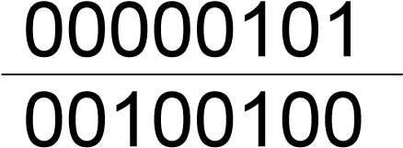
Converted into denary =

+ 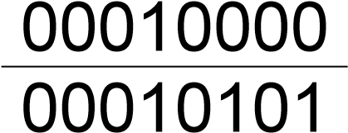
Converted into denary =

+ 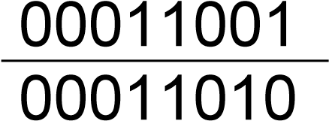
Converted into denary =

+ 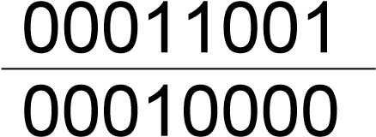
Converted into denary =

Use the table to decrypt the message by writing the letter that is above the denary number you found from the binary sums above. Write each letter in the boxes below to reveal to location of the spy.
The spy and the data are in

A | B | C | D | E | F | G | H | I | J | K | L
1 | 2 | 3 | 4 | 5 | 6 | 7 | 8 | 9 | 10 | 11 | 12
M | N | O | P | Q | R | S | T | U | V | W | X
13 | 14 | 15 | 16 | 17 | 18 | 19 | 20 | 21 | 22 | 23 | 24
Y | Z | a | b | c | d | e | f | g | h | i | J
25 | 26 | 27 | 28 | 29 | 30 | 31 | 31 | 33 | 34 | 35 | 36
k | l | m | n | o | p | q | r | s | t | u | v
37 | 38 | 39 | 40 | 41 | 42 | 43 | 44 | 45 | 46 | 46 | 48
w | x | y | z | ! | * | ( | ) | + | = | & | @
49 | 50 | 51 | 52 | 53 | 54 | 55 | 56 | 57 | 58 | 59 | 60
Overflow error
An overflow error occurs in a computer when the result of a calculation is bigger than the place meant to store it can handle. For example register or storage location can hold 8 bits but the result of a binary addition is 9 bits long not all the answer will fit in the location. In this case the answer will be wrong and an error occurs.
Complete the binary additions below, if the answer is more than a byte (8 bits) write in overflow error as the answer.

01011011

10010110

10110101

00011011

11011011

01111011

11011011

11011110

